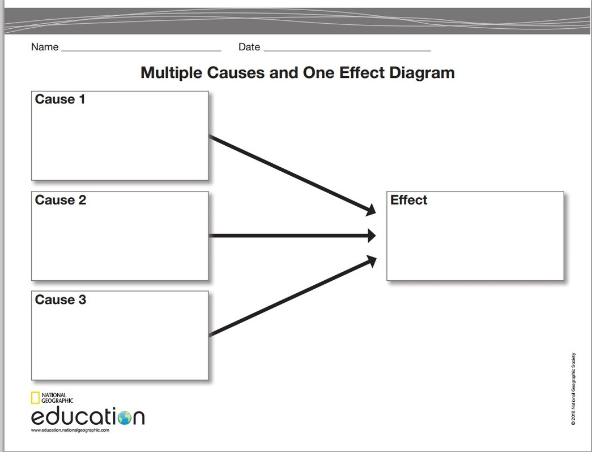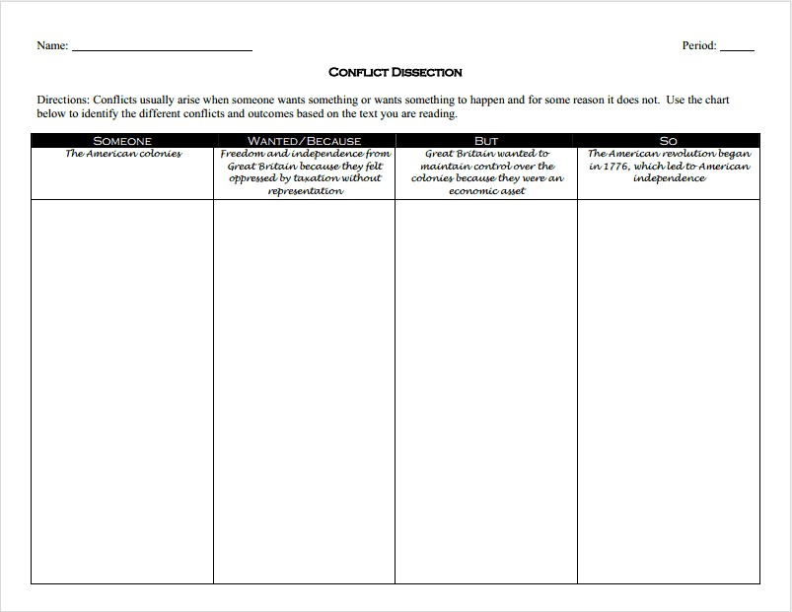

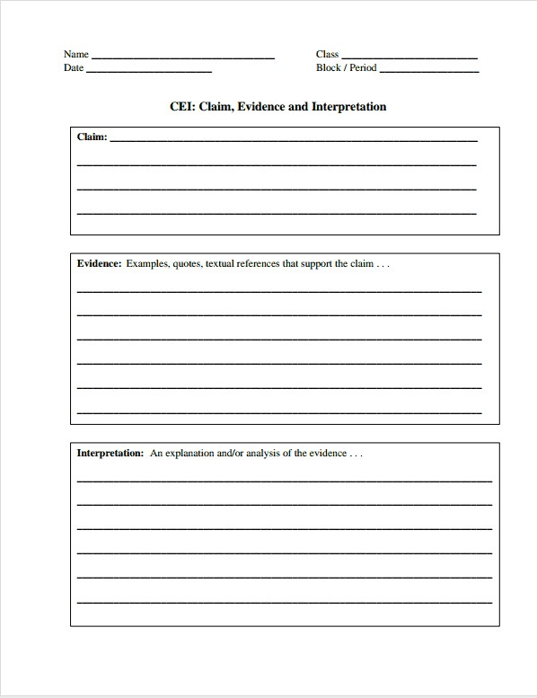





|  |
| --- |
| **Explanation** |



|  |  |  |
| --- | --- | --- |
| **People** | **Goods** | **Ideas** |
|  |  |  |
|  |  |  |
|  |  |  |
|  |  |  |
|  |  |  |

