 | Problem and Solution  adapted from materials posted on the Literacy Leader website, http://www.literacyleader.com
Purpose: to state one or more problems and provide one or more solutions to the problem.
Signal Words and Phrases
advantage |  | disadvantage | question
answer |  | in order to | since
as a result of |  | issue | so that
because |  | led to | solution
cause |  | problem | solved
dilemma |  | puzzle
Comprehension Question Frames
1. What is the problem?
2. Who has the problem?
3. Why is it a problem?
4. What is causing the problem?
5. What solutions have been suggested or tried?
6. What are the pros and cons of various solutions?
7. Which solutions worked or seem to have the best chance for solving the problem?

Graphic Organizers
Solution

Problem | Problem | Problem

Description |  |  | 
Purpose: to explain a topic, concept, person, place, event or object, by providing characteristics, features and/or giving examples.
Signal Words and Phrases
descriptive words (e.g., color, shape, size)
position words (e.g., above, along, beside, between, in front of, near)
appears to be | for example | made up of
characteristics | for instance | most important
consists of | in fact | specifically
features | looks like | such as
Comprehension Question Frames
1. What is the subject being described?
2. How is the topic being described (i.e., where it is, what it does, how it works, what it looks like, its classification)?
3. What are the most important attributes or characteristics?

Web

 | Compare and Contrast
Purpose: to describe what is similar and/or different about two or more subjects.
Signal Words and Phrases
alike |  | but | in comparison | same as
also |  | compared to | in contrast | similar to
although |  | despite | instead of | similarity
as |  | different from | just | too
as opposed to |  | either-or | on the contrary | unlike
as well as |  | however | on the other hand | yet
both |  | in common | opposite
Comprehension Question Frames
1. What subjects are being compared?
2. What is it about them that is being compared?
3. What characteristics of the subjects form the basis of the comparison?
4. What characteristics do they have in common? How are they alike?
5. In what ways are they different?

Graphic Organizer
Alike
Different

Different

 | Chronology/Sequence
Purpose: to provide information in time order or the order in which events, actions, or steps in a process occur.
Signal Words and Phrases
after |  | finally | later | soon
as soon as |  | first/second/third | meanwhile | step
at the same time |  | following | next | then
before |  | immediately | now | today
directions |  | initially | prior to | until
during |  | last | simultaneously | when
Comprehension Question Frames
1. What sequence of events is being described?
2. What are the major events or incidents that occur?
3. What happens first, next, last?
4. How is the sequence or cycle revealed in the text?
5. What are the steps, directions, procedures to follow to make or do something?

Graphic Organizers
STEP 1
STEP 2
STEP 3
STEP 4

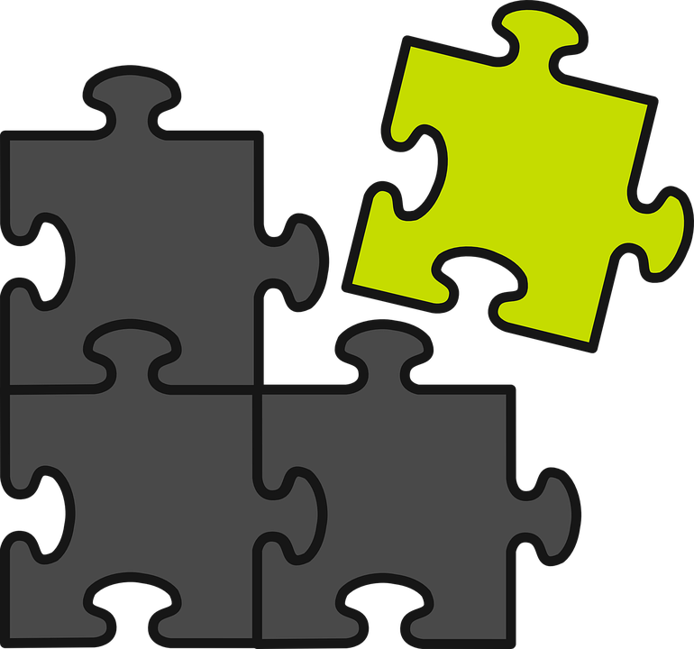 | Cause and Effect
Purpose: to explain why or how something happened/happens
Effect = what happened Cause = why it happened
Signal Words and Phrases
as a result |  | if . . . then | outcome
because |  | impact | reasons for
consequently |  | in order to | since
due to |  | influenced by | so that
effects of |  | is caused by | therefore
for this reason |  | leads to | thus
how |  | on account of | when...then
Comprehension Question Frames
1. What were the specific events that happened?
2. Why did the events happen? What were the causes?
3. What were the results or outcomes of these events happening? What was the effect?
4. Did prior events cause or influence the main event? If so, in what ways?
5. What is the significance of the event and/or the results (outcomes)?

Graphic Organizers
Event
Cause
Cause
Cause
Effect
Effect

Effect

