Academic Language Expert  A+  This certificate is hereby awarded to  _______________________________________  in acknowledgement of his/her  competent use of Academic English | Articulate Speaker  This certificate is hereby awarded to  _______________________________________  for using an eloquent public voice  during a class discussion or presentation
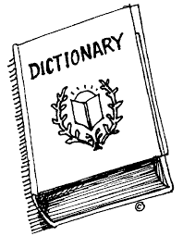  Voracious Vocabulary  This certificate is hereby awarded to  _______________________________________  in acknowledgement of his/her  accurate use of academic vocabulary | 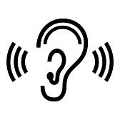  Exceptional Listener  This certificate is hereby awarded to  _______________________________________  for demonstrating attentive listening skills  during class discussions
Fabulous Facilitator  This certificate is hereby awarded to  _______________________________________  for effectively facilitating a  small group or partner discussion | First-Rate Reporter  This certificate is hereby awarded to  _______________________________________  for audibly and thoughtfully reporting  a group’s/partner’s idea(s)
Confident Communicator  This certificate is hereby awarded to  _______________________________________  for speaking in complete  sentences or paragraphs | College & Career-Ready  This certificate is hereby awarded to  _______________________________________  for speaking like a literary critic, scientist, mathematician, historian, or ______________

